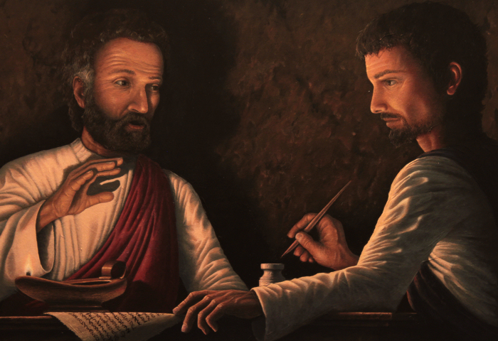

Peter and John Mark
John Mark was Peter’s right hand man: his attendant and writer. Most believe it was John Mark who took down
Peter’s account of the life of Christ, and that it was that account that became the Gospel of Mark. © by Craig Erickson

