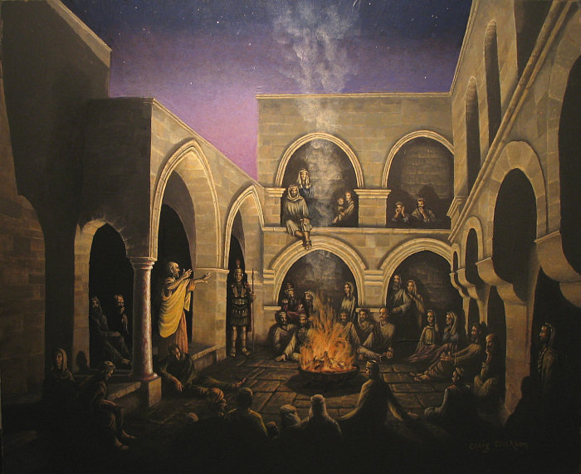

Peter Teaches—Mark Listens—We Benefit
Peter’s teaching likely provides the content for Mark’s Gospel. © by Craig Erickson

